Name: Sanio Luke Sebastian
Roll No: 35
Batch: B
Date: 19-04-2022

ADVANCED DBMS LAB

Experiment No.: 4

Aim
To familiarize with aggregate functions

Questions:

Using the lab cycle 01 database, perform the following queries.

- List total loan
- List total deposit
- List total loan taken from KAROLBAGH branch
- List total deposit of customers having account date later than 1-Jan-96
- List total deposit of customers living in city NAGPUR
- List maximum deposit of customer living in Bombay
- List total deposit of customer having branch in BOMBAY
- Count total number of branch cities
- Count total number of customers cities
- Give branch names and branch wise deposit
- Give city wise name and branch wise deposit
- Give the branch wise loan of customer living in NAGPUR
- Count total number of customers
- Count total number of depositors branch wise
- Count total number of depositors branch wise
- Give maximum loan from branch VRCE
- Give the number of customers who are depositors as well as borrowers

Procedure & Outputs

use lab_cycle_one;

- select sum(amount) from borrow;
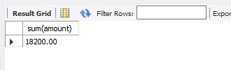

- select sum(amount) from deposit;
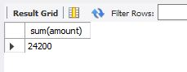

- select sum(amount) from borrow where bname="Andheri";
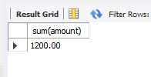

- select sum(amount) from deposit where adate > "1996-01-01";
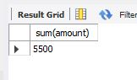

- select sum(d.amount) from deposit d, customer c where d.cname=c.cname and c.city="Nagpur";
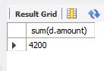

- select max(d.amount) from deposit d, customer c where d.cname=c.cname and c.city="Bombay";
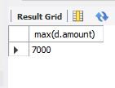

- select sum(d.amount) from deposit d, customer c where d.cname=c.cname and c.city="Bombay";
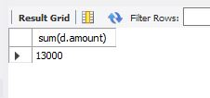

- select count(distinct(city)) from branch;
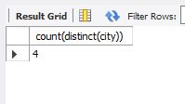

- select count(distinct(city)) from customer;
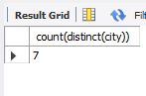

- select bname, sum(amount) as sum from deposit group by bname;
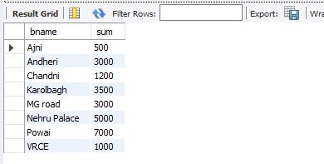

- select c.city, sum(d.amount) from customer c, deposit d where d.cname=c.cname group by c.city;
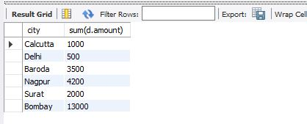

- select bo.bname, sum(bo.amount) from borrow bo, branch br where bo.bname=br.bname and br.city="Nagpur";
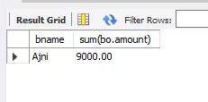

- select count(*) from customer;
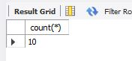

- select bname,count(*) from deposit group by bname;
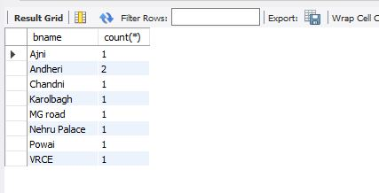

- select max(amount) from borrow where bname="VRCE";
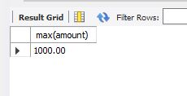

- select count(cu.cname) from customer cu, borrow bo, deposit d where cu.cname=bo.cname and cu.cname=d.cname;
